**Smart Farmer-IOT Enabled Smart Farming Application**

IBM NALAIYATHIRAN

**Solution Architecture**

|  |  |
| --- | --- |
| **TITLE** | **Smart Farmer-IOT Enabled Smart Farming Application** |
| **DOMAIN NAME** | INTERNET OF THINGS |
| **TEAM ID** | PNT2022TMID31496 |
| **LEADER NAME** | V MANOJ KARTHIK |
| **TEAM MEMBER NAME** | JEEVETH P  JINI S S  KOKILA C |
| **MENTOR NAME** | NANDHINI S |

**Solution Architecture:**

* The different soil parameters (temperature, humidity, light intensity, pH level) are sensed using different sensors and the obtained value is stored in IBM cloud.
* Arduino UNO is used as a processing unit which processes the data obtained from sensors and weather data from weather API.
* Node red is used as a programming tool to wire the hardware, software and APIs. The MQTT protocol is followed for communication.
* All the collected data are provided to the user through a mobile application which was developed using MIT app inventor. The user could make decision through an app, whether to water the crop or not depending upon the sensor values.

**Solution Architecture Diagram:**

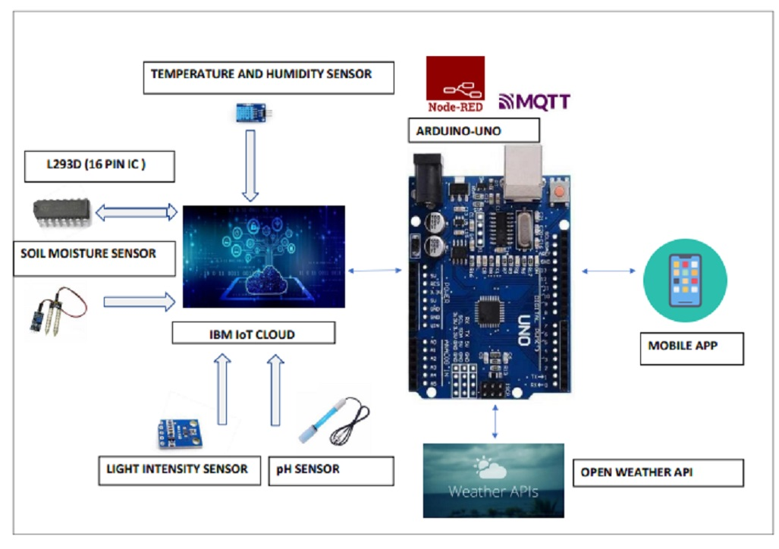

­­

**Reference:** [**https://aws.amazon.com/blogs/industries/voice-applications-in-clinical-research-powered-by-ai-on-aws-part-1-architecture-and-design-considerations/**](https://aws.amazon.com/blogs/industries/voice-applications-in-clinical-research-powered-by-ai-on-aws-part-1-architecture-and-design-considerations/)